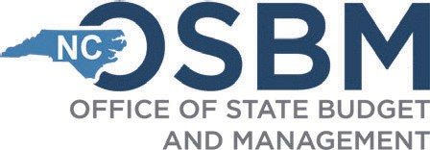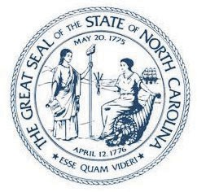STATE OF NORTH CAROLINA Office of State Budget and Management

Employment First State for Individuals with Disabilities

Roy Cooper

Governor

KRISTIN WALKER

State Budget Director

October 15, 2024

MEMORANDUM

TO: Senator Michael Lee, Chair of the Senate Committee on

Appropriations/Base Budget

Senator Ralph Hise, Chair of the Senate Committee on Appropriations/Base Budget

Senator Brent Jackson, Chair of the Senate Committee on Appropriations/Base Budget

Representative Dean Arp, Chair of the House Appropriations Committee Representative Donny Lambeth, Chair of the House Appropriations Committee Representative Jason Saine, Chair of the House Appropriations Committee Brian Matteson, Director of Fiscal Research Division

FROM: Stephanie McGarrah, Director of the NC Pandemic Recovery Office SUBJECT: State Fiscal Recovery Funds (SFRF)

Per Session Law 2021-180, Section 4.9.(i), the North Carolina Pandemic Recovery Office (NCPRO) is required to submit a report to the Senate Committee on Appropriations/Base Budget, House Appropriations Committee, and Fiscal Research Division on the use of State Fiscal Recovery Funds, including the amount of funds disbursed to each State agency, State department, and nonprofit organization; the amount of funds remaining to be disbursed to each State agency, State Department, and nonprofit organization; and how the funds were used by each State agency, State department, and nonprofit organization.

NCPRO has launched an online State Fiscal Recovery Fund Dashboard that provides the necessary financial and performance data to satisfy the reporting requirements outlined above.

Please visit: <https://ncpro.nc.gov/data-research/covid-19-funding-dashboard-hub/state-fiscal-recovery-fund-dashboard>

If you have questions, please email them to [stephanie.mcgarrah@osbm.nc.gov.](mailto:stephanie.mcgarrah@osbm.nc.gov)

**Mailing address:**

**20320 Mail Service Center Raleigh, NC 27699-0320**

[**www.osbm.state.nc.us**](http://www.osbm.state.nc.us/)

**984-236-0600 ** FAX: 984-236-0630**

**An EEO/AA Employer**

**Office location: 116 West Jones Street Raleigh, NC 27603**